**Project Name - Sporty Shoe**

**Introduction**

Sporty shoe is a E- commerce portal that helps people buy sporty & Latest Fashion design shoe directly from the website.

This document describes the implementation of Sporty shoe and how its users can interact with the application.

**Objectives**

The objective of this document is to describe how the solution of Sporty shoe will interact with User.

This document also provides information on end-to-end workflow so that business users can understand the features and functionalities of the Sporty shoe an online E-Commerce portal for Sport Shoes.

The workflow mainly involves the following important aspects-

**For Users-**

1. A login page for user that helps in maintaining privacy of the user and helps in keeping track what shoes user purchase earlier
2. A homepage that allows user to choose the shoe user likes in accordance to his/her preferences.
3. Based on user preference user can remove items from cart if user didn’t want to purchase those items.
4. Once user decided what he/she wants to purchase can check out through a secure gateway.
5. If he/she is not a user they will be taken to the registration page.
6. User can edit their profile if they are already registered.
7. On completion of the payment, they are shown a page with the details of the items they have purchased.

**For Admin-**

Admin can only login but can’t create any account. New account can be created from backend only.

Admin can setup products that company wants to sell on the portal.

Admin can Categorize each product on the portal like sneaker, sport shoe etc.

Admin can see how many members are signed up in the portal.

Admin can see per user purchase report.

Admin can change password of his/her account.

**Technical Aspects:**

Language used – java

Framework- spring core, Hibernate,JSP

Database used MySQL.

Tool used: - Spring Tool Suite 4 as code editor and MySQL workbench.

**Duration of Sprints required:**

I have divided this application in 1 sprints of 7 days each. In first day I made a plan to how to create the application, the next 2 days I developed the application code for User page and in next 2 days I write code for Admin part and creation of database in workbench and created CSS and other design aspects on the 6th day and the last day of the first sprint I tested whole the Application and made the documentation.

**Flow Chart for User:**

Complete Checkout

Make Payment

Checkout Now

Remove

Want to buy?

Add to cart

Your orders

Edit Profile

HomePage

Dashboard

Not a member?

Login

Home

**Start**

Signup

No

Yes

No

Yes

Logout

**Stop**

**Flow Chart for Admin:**

**Start**

Logout

**Stop**

Delete category

Edit category

Add category

Delete Product

Edit Product

Add Product

Setup Product categories

Setup Products

Purchase Report

Browse Members

Change Password

Dashboard

Login

Enter valid admin ID and password

Screen Shots of the Project: -

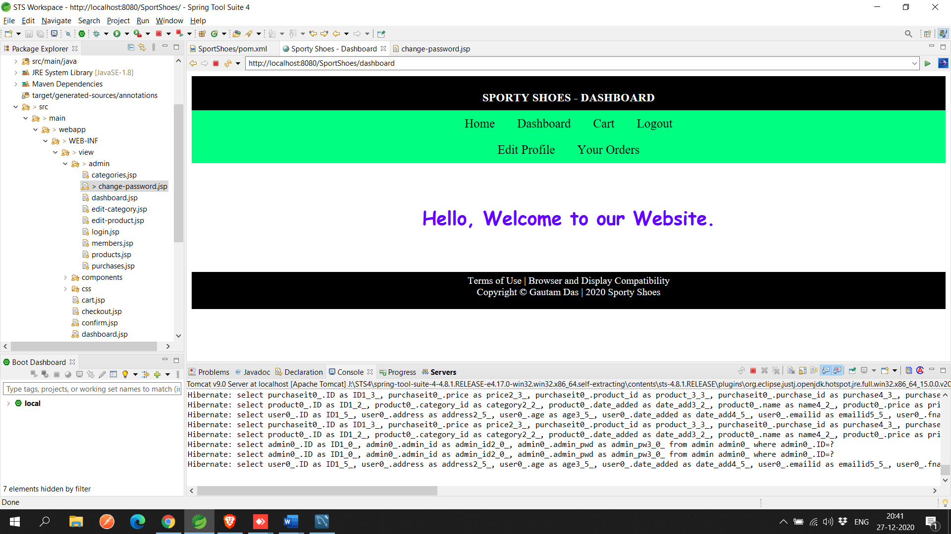

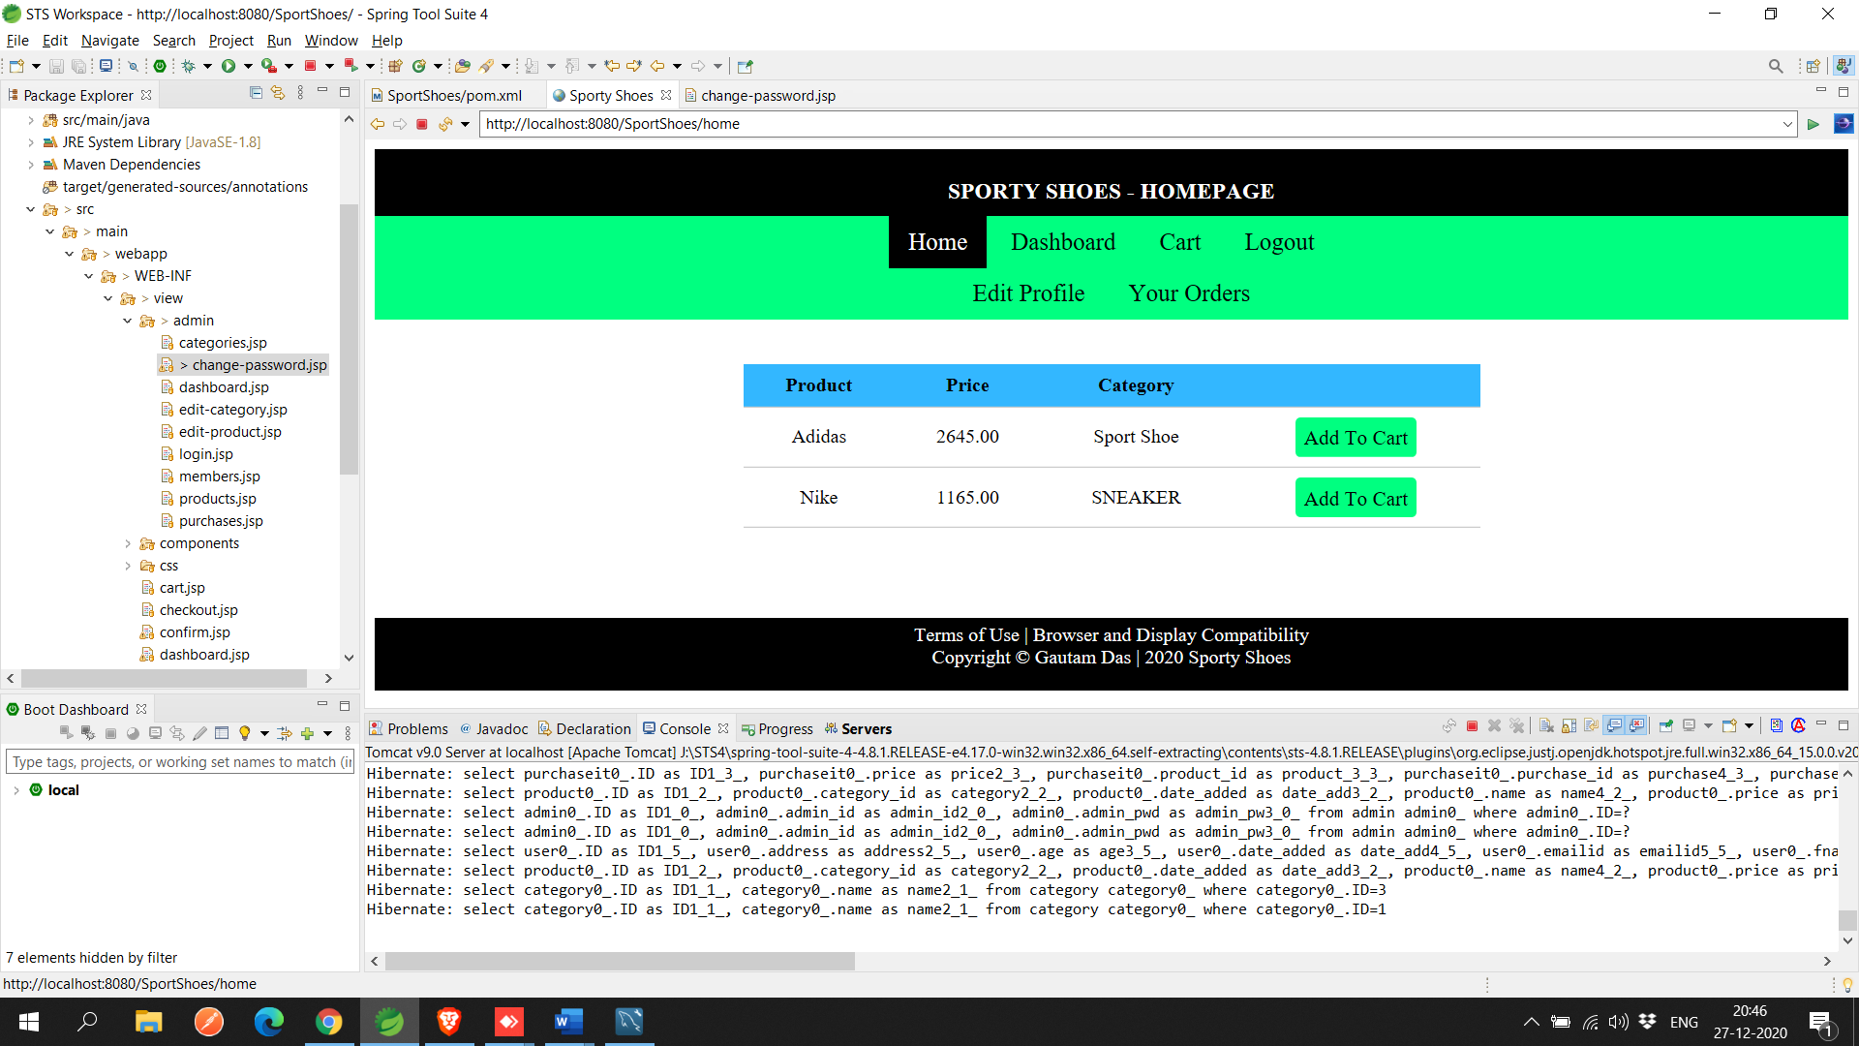

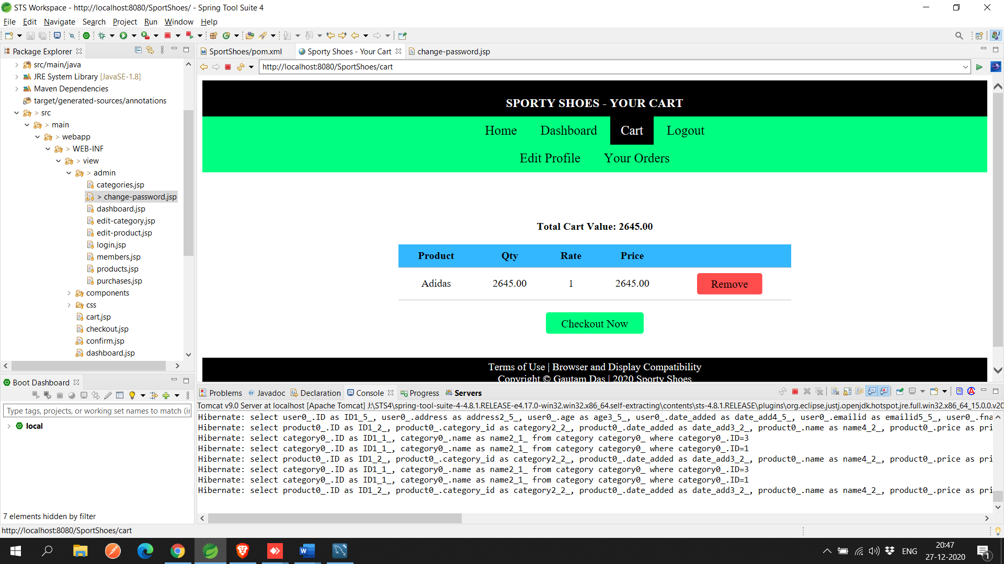

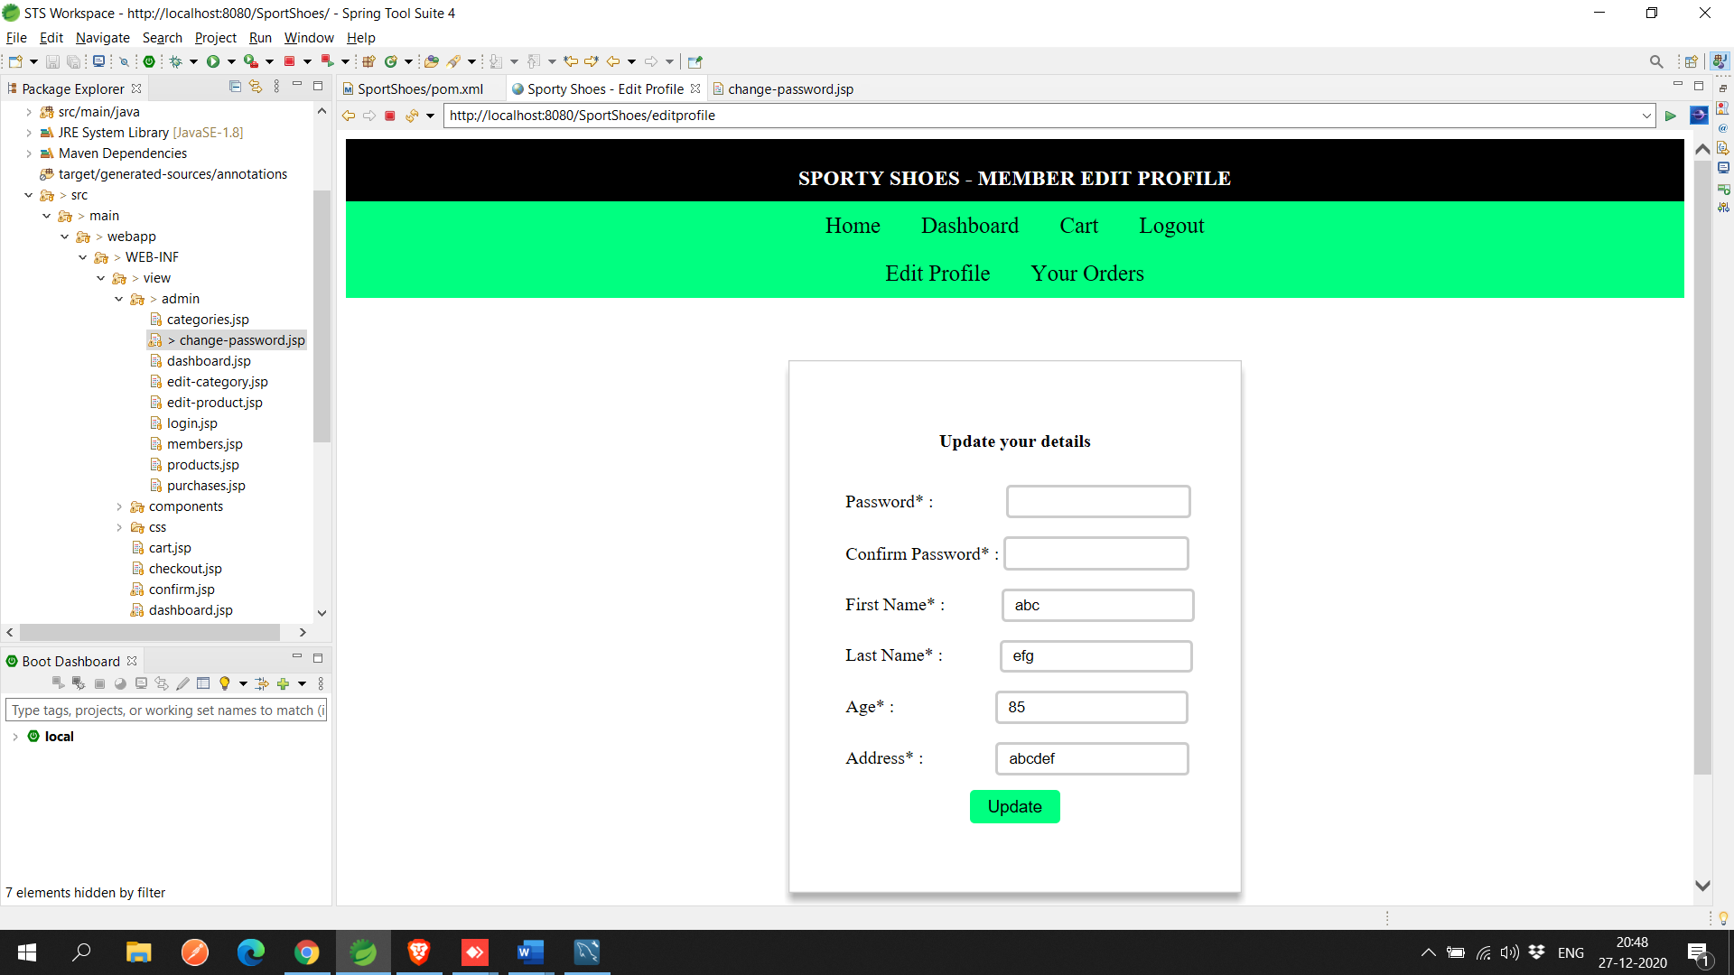

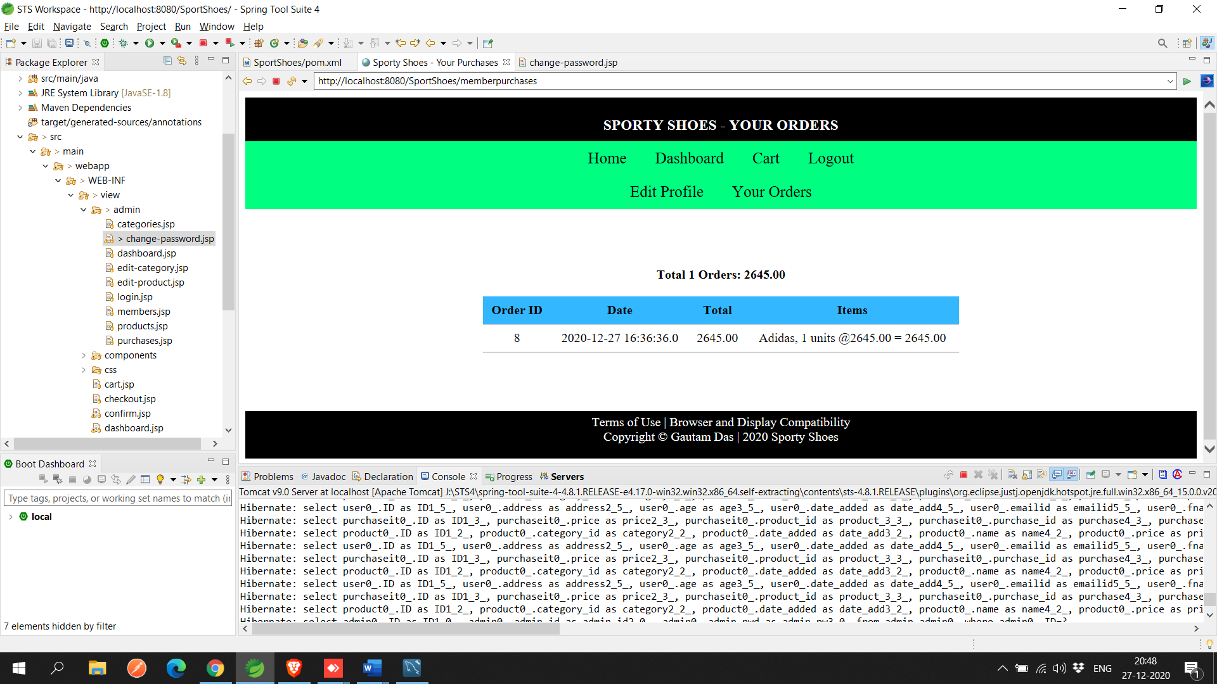

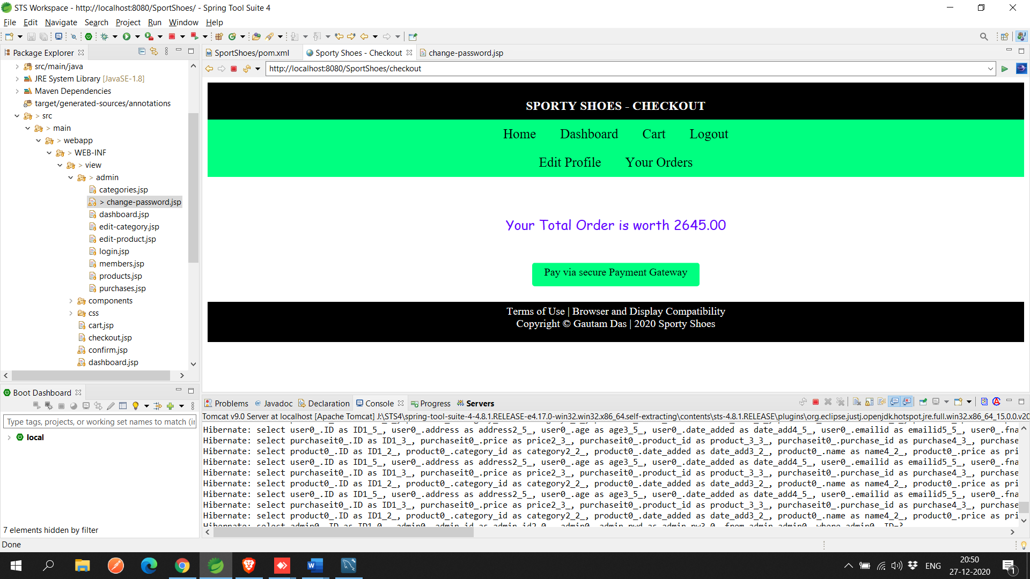

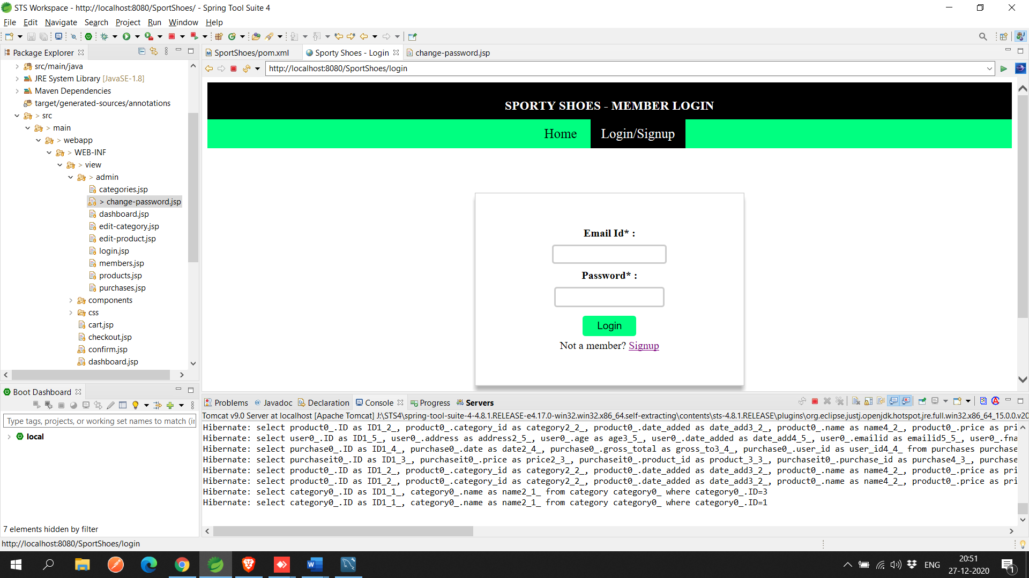

**For Admin :**

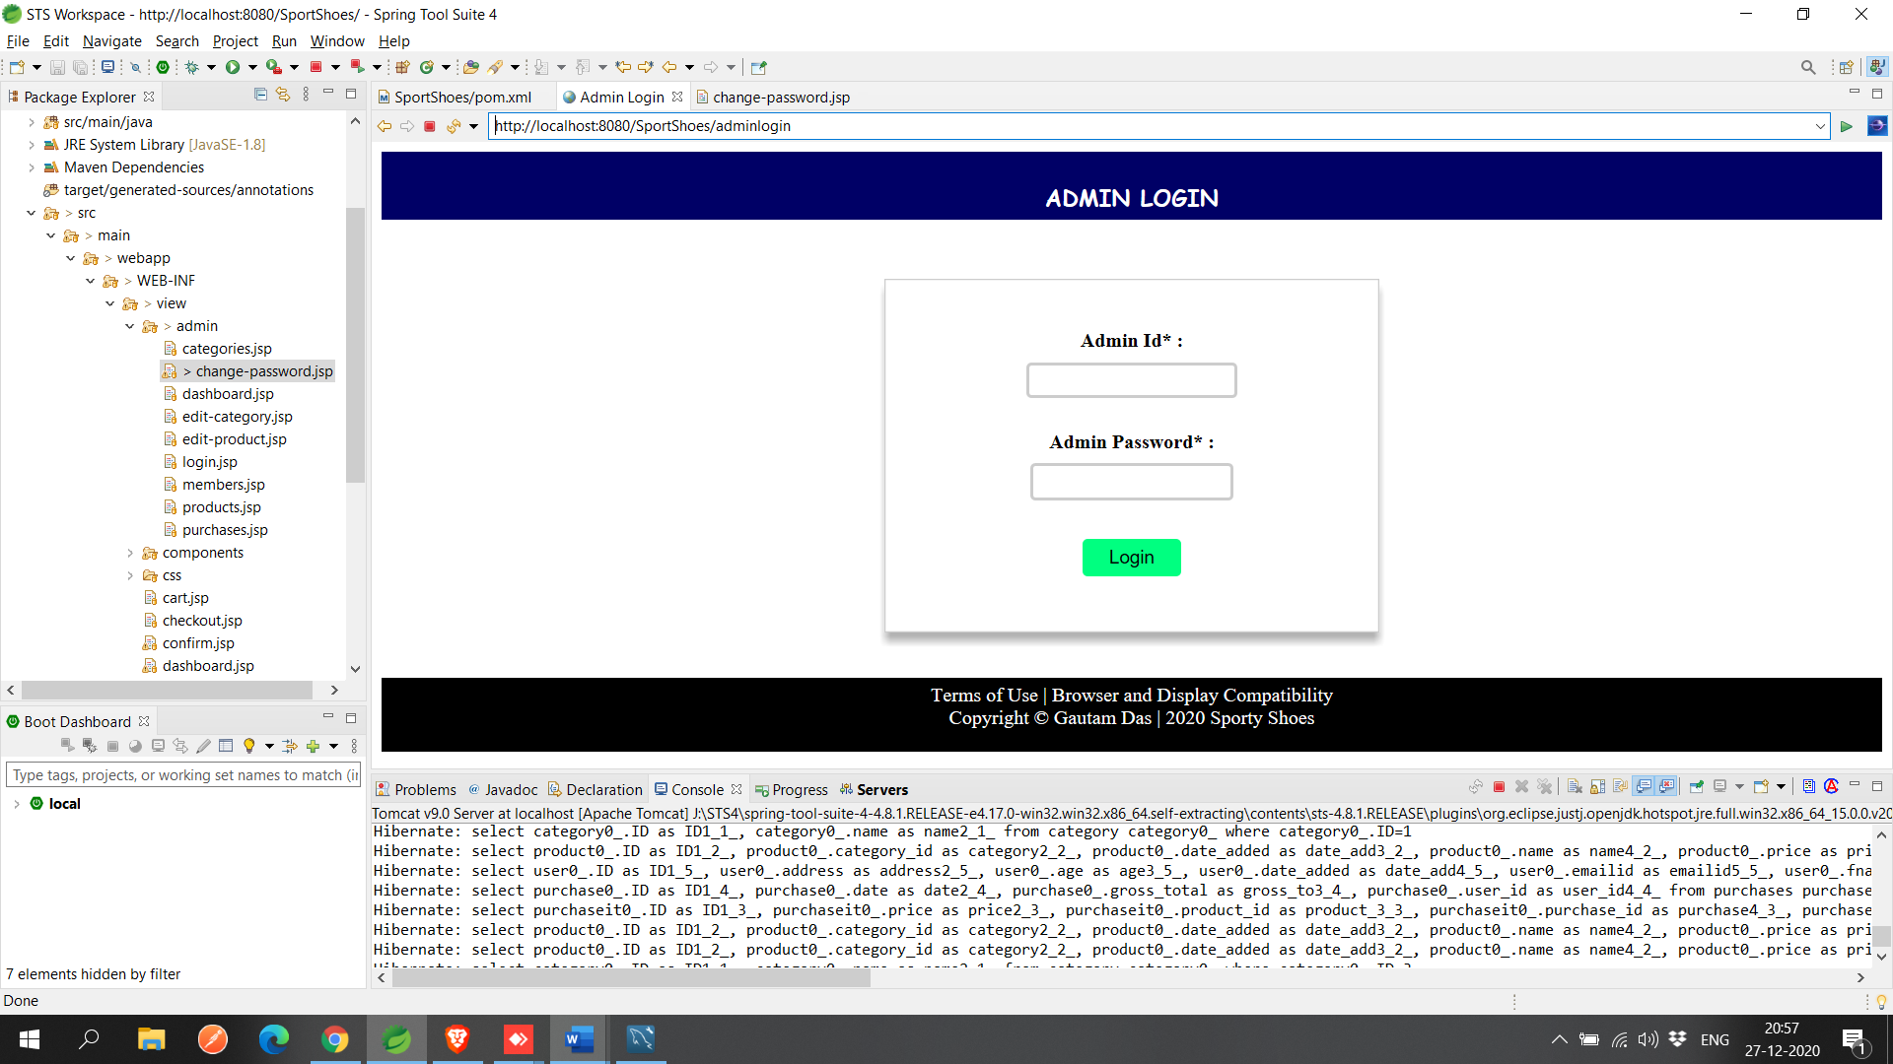

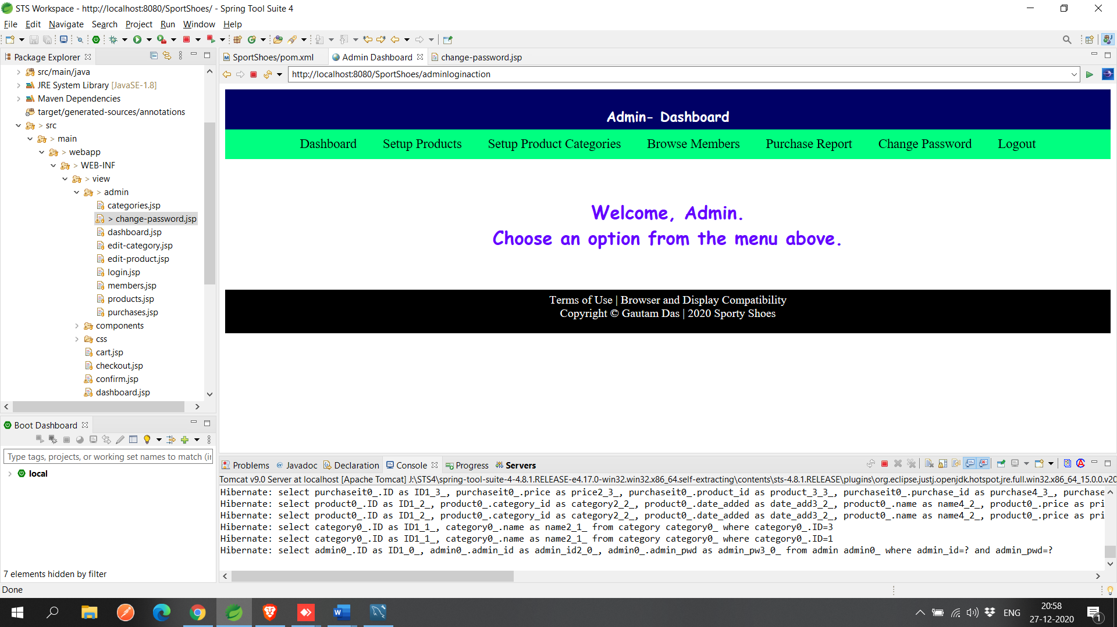

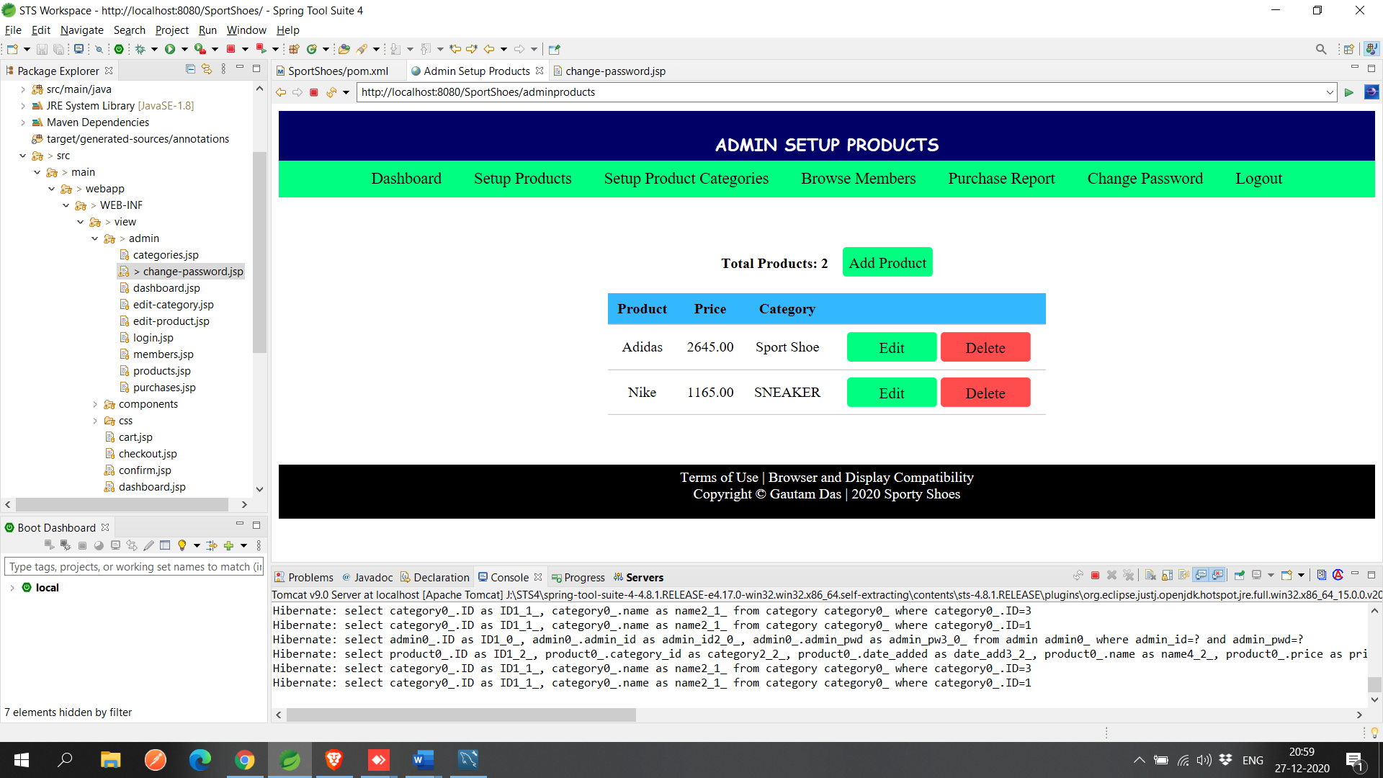

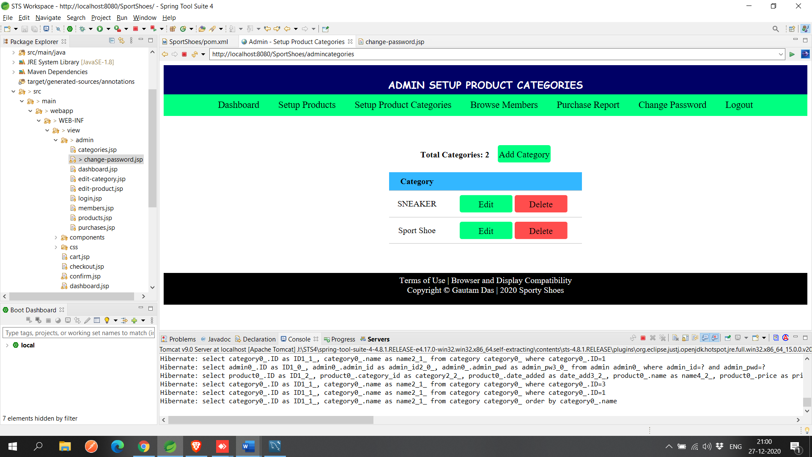

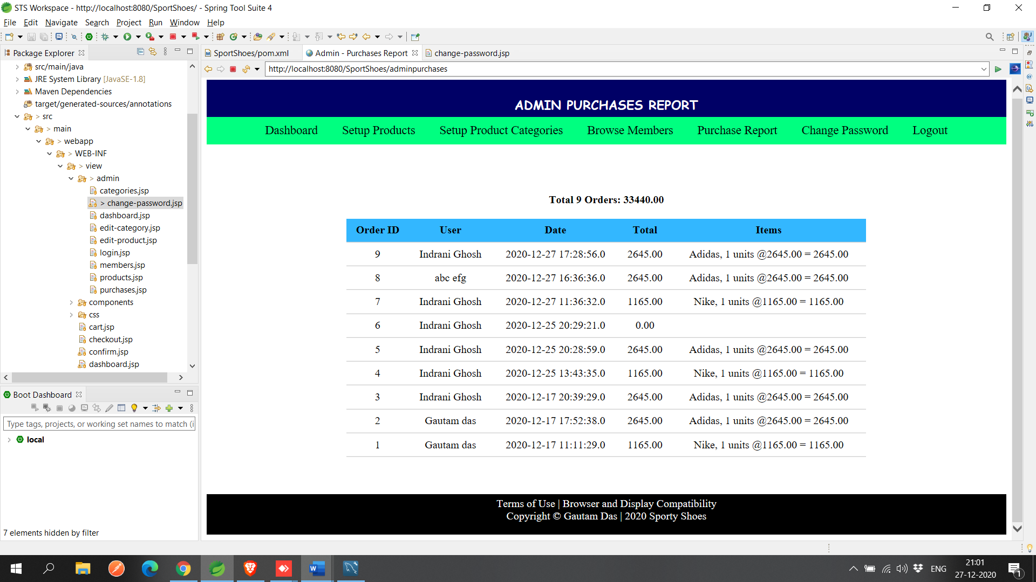

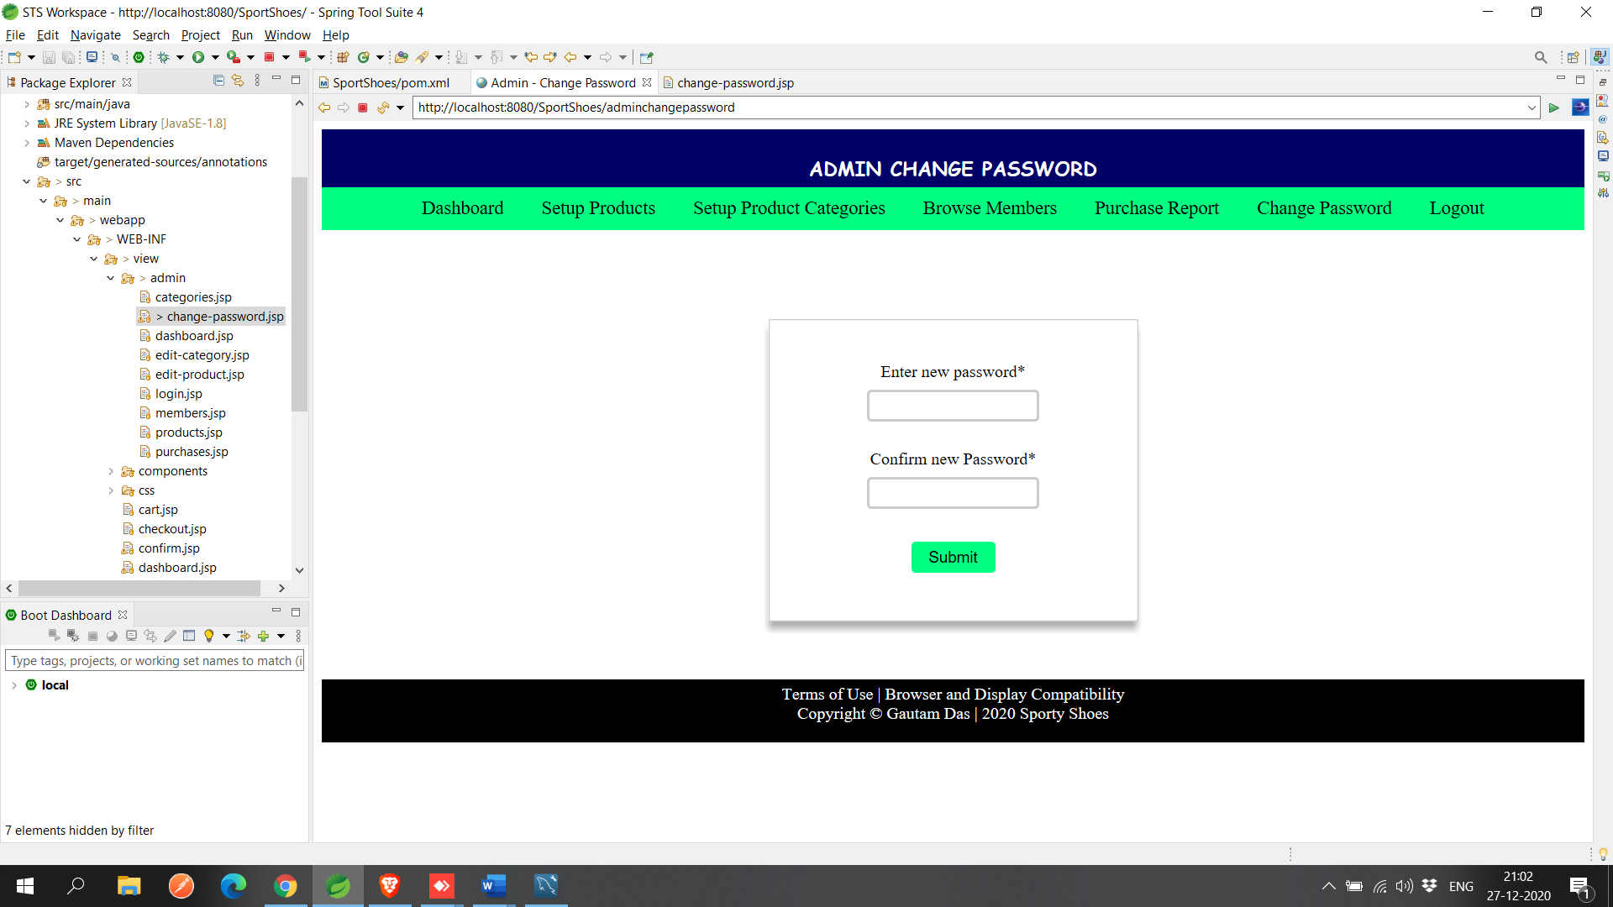

DataBase used:

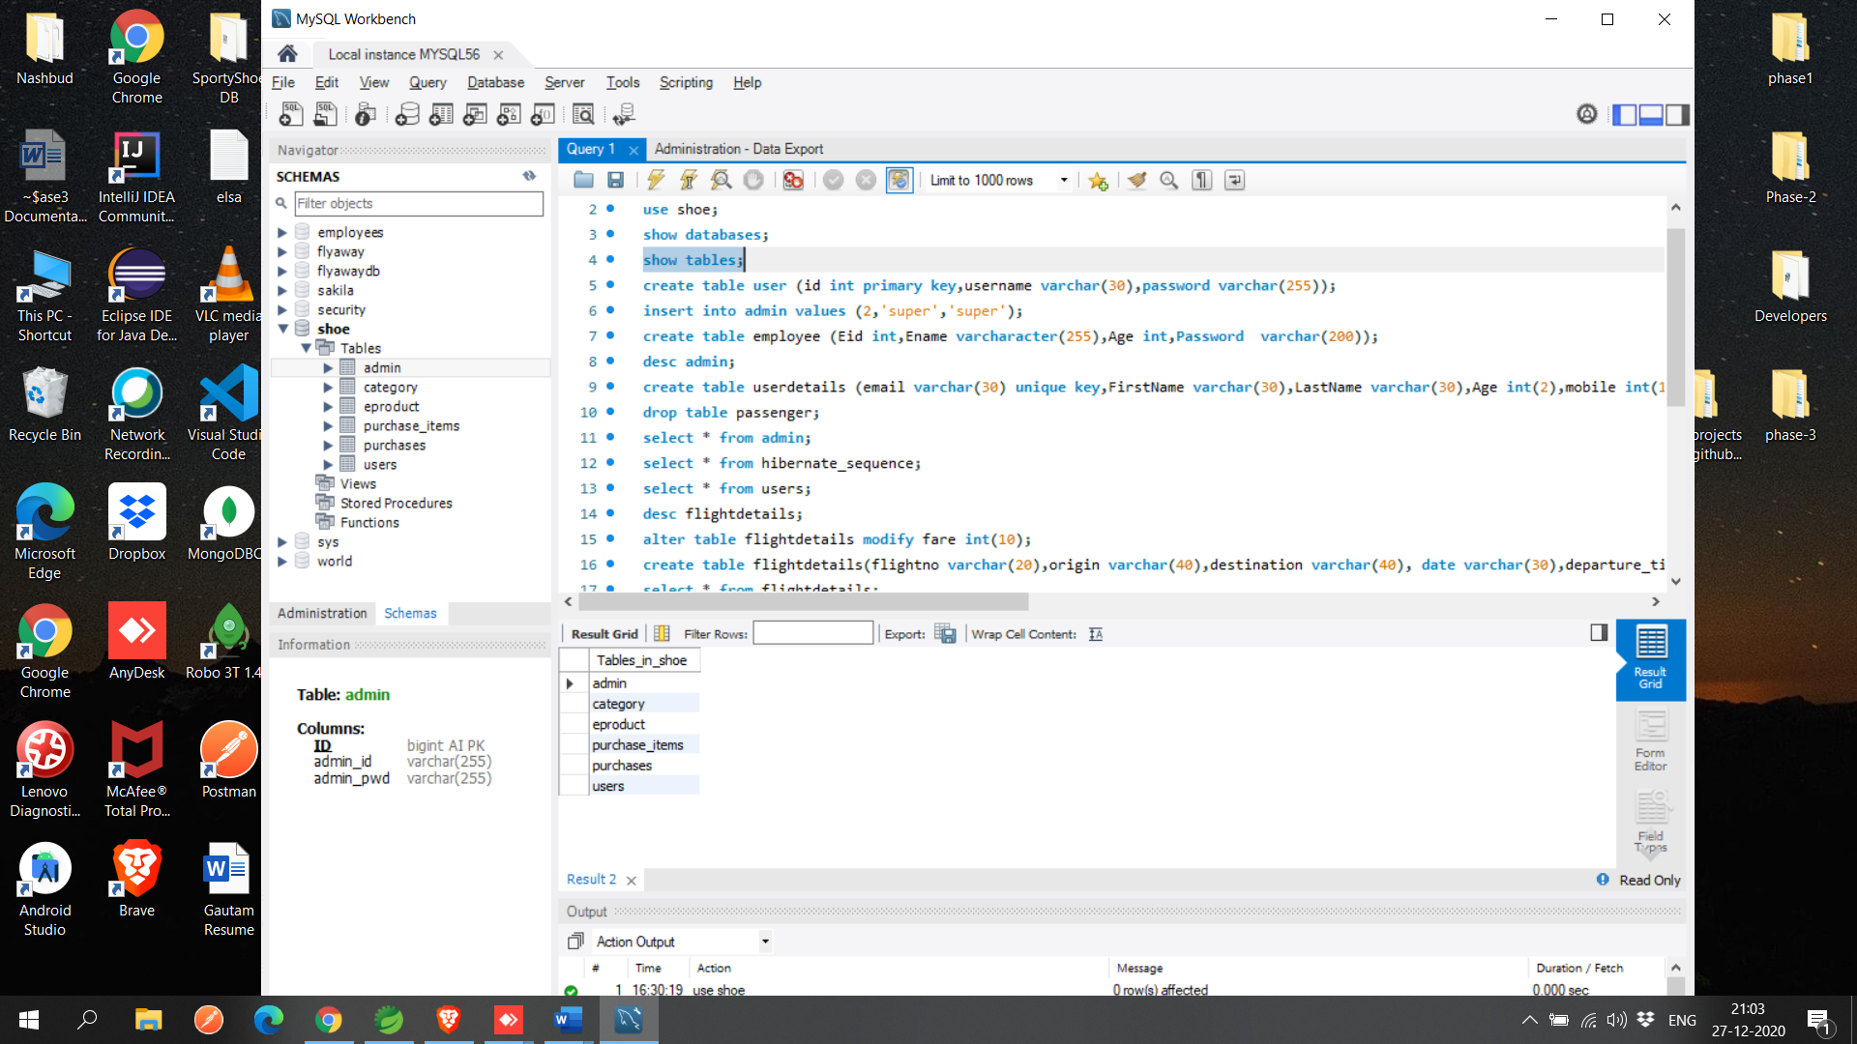

**Git Hub Link-**

[**https://github.com/codergautam25/phase3-SportyShoe.git**](https://github.com/codergautam25/phase3-SportyShoe.git)